**INDEX**

SI no: Contents Page No.

1. Introduction 1

2. Design Of Project 1

3. Basics Of HTML 2-3

4. Tags Used In Project 3-5

5. Results And Analysis 6-8

**INTRODUCTION 1**

This is dynamic website which gives all the information about programming and the basics of C++ And its fundamentals.

The website has been developed in HTML and CSS is a markup language which is in reality a backbone of any site, every site can’t structured without the knowledge of html.

If we make our web page only with the help of html, than we can’t add many of the effective features in a web page, for making a web page more effective we use various platforms such as CSS.

So here we are using these entire features to make our web pages more effective as well as efficient.

And to make our web pages dynamic we are using CSS here.

**Design Of Project**

It’s designed to make the interaction very simple and basic. A header that contains the key points present in the webpage which is useful to jump to the needed points present in the webpage.

HTML and CSS is used to design this project it provides built in container themes and other necessary tools.

**Basics Of HTML 2**

Below mentioned are the basic HTML tags which divides the whole document into various parts like head, body etc.

• Every HTML document begins with a HTML document tag. Although this is not mandatory but it is a good convention to start the document with this below mentioned tag:

<!DOCTYPE html>

• <html> : Every HTML code must be enclosed between basic HTML tags. It begins with <html> and ends with </html> tag.

• <head> : The head tag comes next which contains all the header information of the web page or document like the title of the page and other miscellaneous information. These informations are enclosed within head tag which opens with <head> and ends with </head>. The contents will of this tag will be explained in the later sections of course.

• <title> : We can mention the title of a web page using the <title> tag. This is a header information and hence mentioned within the header tags. The tag begins with <title> and ends with </title>

• <body> : Next step is the most important of all the tags we have learned so far. The body tag contains the actual body of the page which will be visible to all the users. This opens with <body> and ends with </body>. Every content enclosed within this tag will be shown on the web page be it writings or images or audios or videos or even links. We will see later in the section how using various tags we may insert mentioned contents into our web pages.

**3**

The whole pattern of the code will look something like this:

<html>

<head>

<!-- Information about the page -->

<!--This is the comment tag-->

<title>Title of the webpage </title>

</head>

<body>

<!--Contents of the webpage-->

</body> </html>

**Tags Used In Project**

Heading Tags

Any document starts with a heading. You can use different sizes for your headings. HTML also has six levels of headings, which use the elements <h1>, <h2>, <h3>, <h4>, <h5>, and <h6>. While displaying any heading, browser adds one line before and one line after that heading.

Paragraph Tag

The <p> tag offers a way to structure your text into different paragraphs. Each paragraph of text should go in between an opening <p> and a closing </p> tag

**4**

Hyperlink Tag

The <a> tag defines a hyperlink, which is used to link from one page to another.

The most important attribute of the <a> element is the href attribute, which indicates the link's destination.

Header And Footer Tag

The <header> element represents a container for introductory content or a set of navigational links.

The <footer> tag defines a footer for a document or section.

Table Tag

The <table> tag defines an HTML table.

An HTML table consists of one <table> element and one or more <tr>, <th>, and <td> elements.

The <tr> element defines a table row, the <th> element defines a table header, and the <td> element defines a table cell.

Video Tag

The <video> tag is used to embed video content in a document, such as a movie clip or other video streams.

**5**

The <video> tag contains one or more <source> tags with different video sources. The browser will choose the first source it supports.

Style Tag

The <style> tag is used to define style information (CSS) for a document.

Inside the <style> element you specify how HTML elements should render in a browser.

Meta Tag

The <meta> tag defines metadata about an HTML document. Metadata is data (information) about data.

<meta> tags always go inside the <head> element, and are typically used to specify character set, page description, keywords, author of the document, and viewport settings.

Image Tag

The <img> tag is used to embed an image in an HTML page.

Images are not technically inserted into a web page; images are linked to web pages. The <img> tag creates a holding space for the referenced image.

**6**

**Results And Analysis**

**Home Page :**

The home page contains a header with the title of the course along with a button container in the middle that links to the c-programming fundamentals webpage and a footer that has the credits.

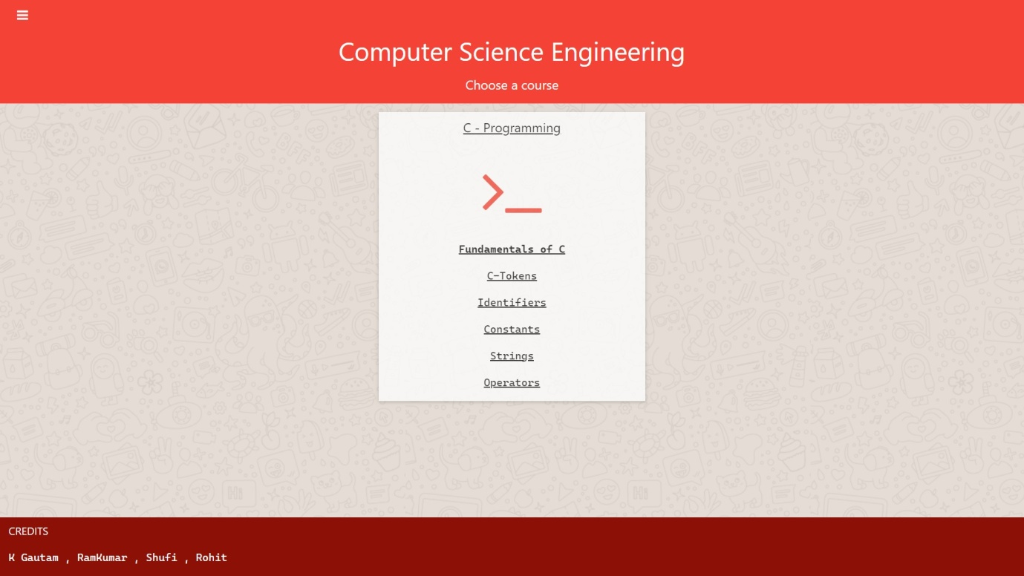

**7**

**C-programming page :**

This Page Contains the actual content of the project. There is a header present in the webpage that has some quick access buttons. There is a home icon button which links to the homepage. The other buttons are for jumping on various points in the webpage for easier navigation.

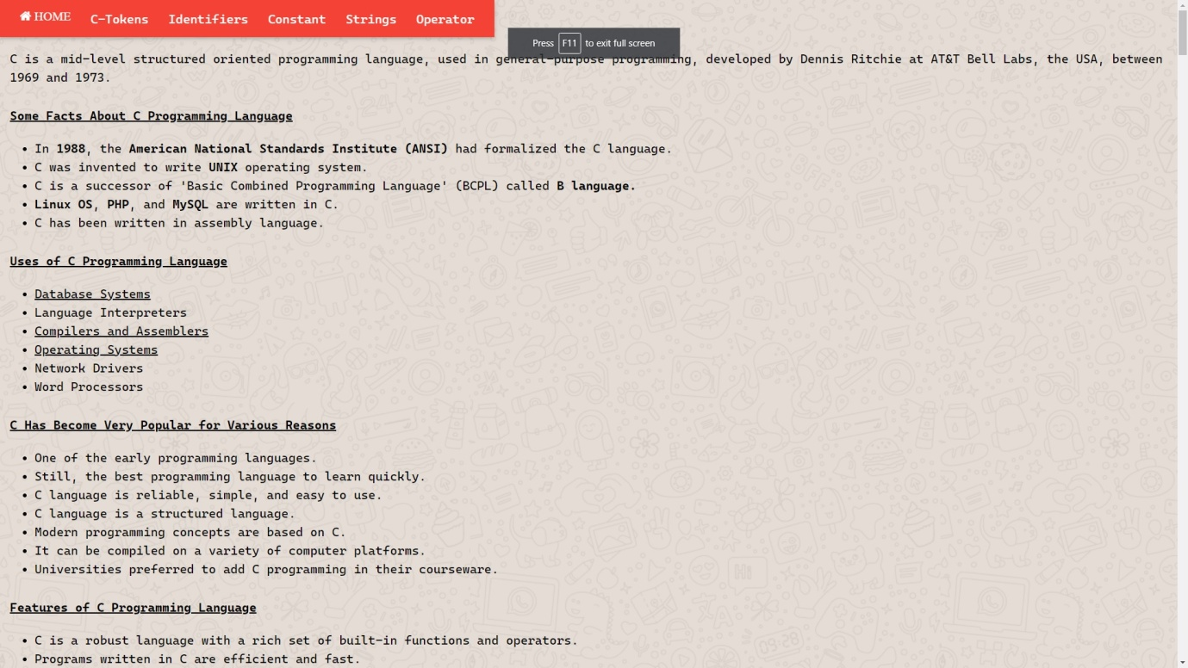

**8**

